Development of educational resources
Proyecto Eco4 is an educational project focused on raising awareness and learning about the Sustainable Development Goals (SDGs). UIC Barcelona, with the collaboration of different educational organisations and the non-profit foundation Justicia i Pau, aims to create a network of educational institutions and entities that work together to promote integral ecology and global justice. The project encourages young people to overcome superficial changes and address the root causes of social and environmental challenges from a positive perspective. Dr Mariona Graells directed this methodological research from the transformation of social reality, vulnerability and the environment.

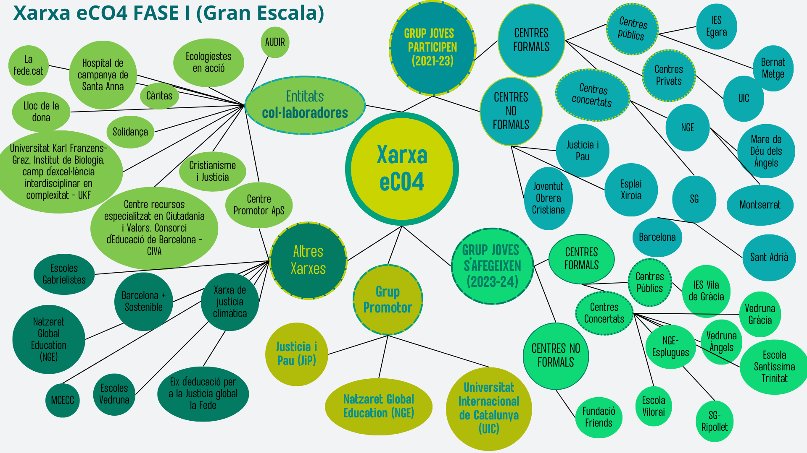
As part of the Empremta CO⁴ (eCO⁴) research project, the first meeting on the concept of commitment took place on 26 January 2024. Various educational centres and young activists had the opportunity to share their insights on what it takes to take action.
During the 2023–2024 academic year, the third phase of the project —commitment— was launched. Through a transformative service-learning (ApS) educational approach, which includes shared action–reflection dynamics, participants are building a network of young people committed to global justice and integral ecology, involving schools and organisations, the local community, and decision-making institutions.
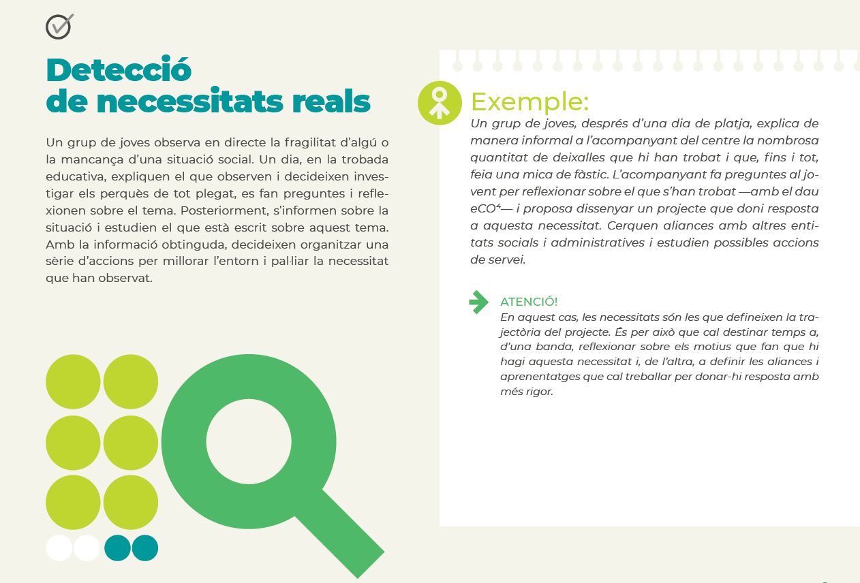
This image is an example of the practical guide or the implementation of this educational resource designed for young students.
Empremta CO⁴ Guide: Part 1: Project Description and Part 2: Get Involved.

A+Familias is an association that provides debit cards to vulnerable families. The Joaquim Molins Figueras Chair of UIC Barcelona studies the impact of this aid on the well-being of families.

Service Learning is an educational approach through which students develop their skills by participating in a project aimed at meeting a real need within a community, thereby improving people’s living conditions. The initiative works towards SDGs 1, 3, 4, 5, and 10.
Academic objectives are linked to the resolution of social challenges. This methodology has been implemented since 2006 in various courses and is connected to teaching innovation projects. Students have always had the opportunity to engage in ApS through School Placements III, in hospital classrooms across Catalonia, rural schools in Guatemala, and the Arrabal neighbourhood in Barcelona.
During the 2023–2024 academic year, the methodology was applied in the following courses:
- School Placements III (Bachelor’s Degree in Early Childhood Education): community service to support the integration of families in situations of social vulnerability.
Coordinator: Dr. M. Teresa Fuertes. Casal dels Infants de Badalona.
- School Placements III (Bachelor’s Degree in Primary Education): service focused on improving communication within hospital classroom contexts.
Coordinator: Dr. M. Teresa Fuertes. Hospital Classroom, Germans Tries i Pujol, Badalona.
- Language Learning and Literacy III (Bachelor’s Degree in Early Childhood Education): community service project teaching storytelling techniques to secondary school students in Ciutat Meridiana, Barcelona.
Coordinator: Dr. Mariona Graell.
- Systematic Observation and Context Analysis (Bachelor’s Degree in Early Childhood Education): service project consisting of a food collection campaign across UIC Barcelona’s Health Campus.
Coordinator: Dr. Mariona Graell.
Additionally, projects promoting reading initiatives and women’s empowerment in rural areas of Guatemala were presented, as well as the AIDIR Ciutat Vella Unit, a corporate social responsibility project led by the Nursing Department in its ongoing commitment to improving the health of the population it serves.
Kids Sustainability is a project led by the Ignatianum University in Krakow (Poland), in which the universities LUMSA (Rome), the Polytechnic of Milan (Italy), Dublin City University (Ireland), and UIC Barcelona (Spain) collaborate. It aims to design learning resources for educators based on research for children aged 3 to 6 years that are focused on developing sustainability skills with an outdoor approach. The project repository houses practical learning resources designed to help teachers and parents identify and strengthen sustainability skills development practices and how to teach them.

Green Dialogs is an international teaching and research programme aimed at promoting international collaboration in the field of children’s environmental literature to enhance educational quality. It also facilitates the exchange of university staff among partner institutions: UIC Barcelona, the University of Padua, and the Western Norway University of Applied Sciences.
During the Green Dialogues Meeting, efforts were made to encourage a genuine exchange of thoughts and ideas to explore how children’s literature represents nature and to deepen the connections between linguistic diversity and sustainability. In addition, the selection of works curated by the Education Section of the Sant Cugat Campus Library has helped to disseminate the project and raise awareness of these titles and their messages throughout the university community.

