University: Universitat Internacional de Catalunya (UIC)
Country: Spain
Web Address: www.uic.es/en

[2] Energy and Climate Change (EC)

[2.10] Greenhouse gas emission reduction programme

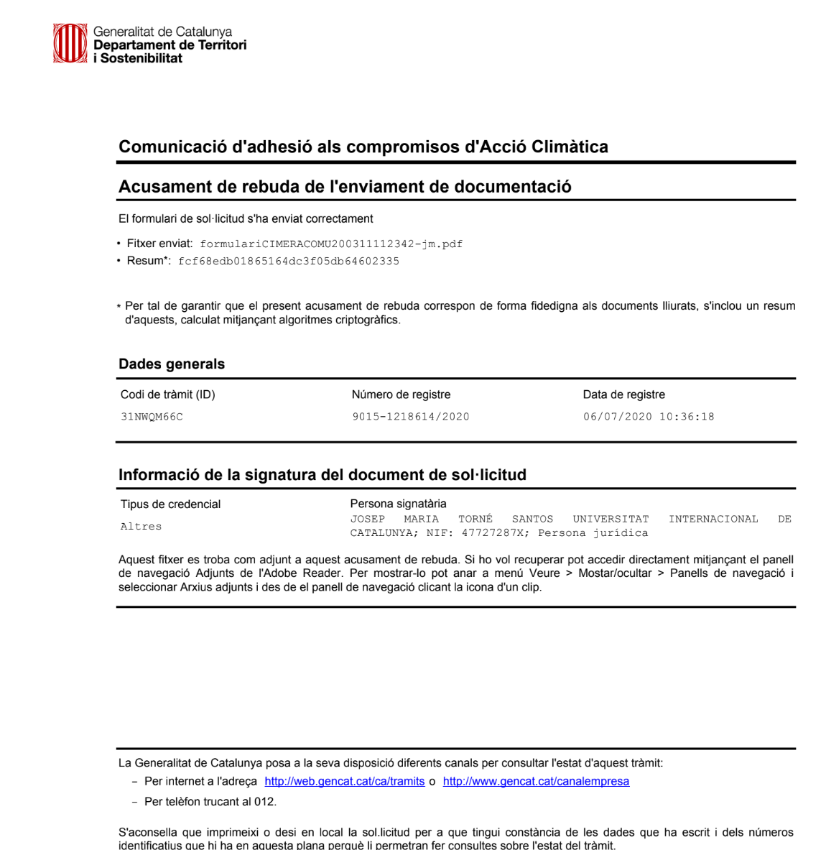

Figure 1. Certificate signed by the manager with the Generalitat (Universitat Internacional Catalunya,Spain)
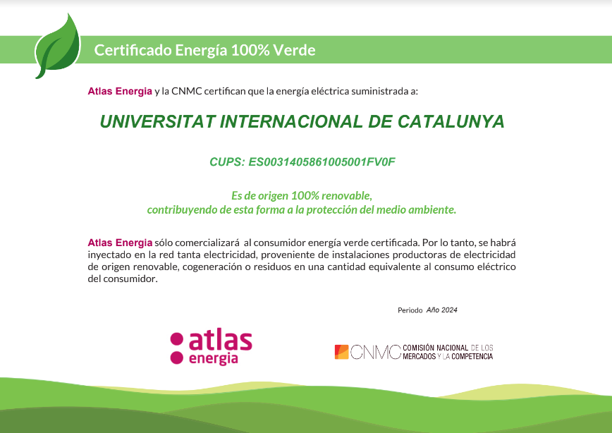
Figure 2. Atlas Energia's 100% renewable energy certificate
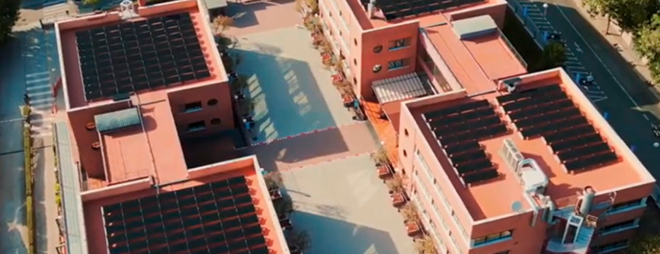
Figure 4. The University reaffirms its commitment to sustainability with the installation of
solar panels on the Barcelona Campus.

Description:

The current situation at our university regarding the implementation of programmes and actions to reduce greenhouse gas emissions is as follows:
According to the List of greenhouse gas emission sources (Woo & Choi, 2013), the following are taken into account:
- Scope 1
  - Stationary combustion. The heating system at UIC Barcelona can be operated using either a boiler or climate control units. At present, priority is being given to the use of climate control units.
  - Mobile combustion: The burning of fuels by vehicles owned by the institution. The UIC Barcelona vehicle fleet includes a fully electric van, a Nissan e-NV200, and a hybrid vehicle under a leasing arrangement, a Mazda CX-5.
- Scope 2
  - Purchased electricity. Indirect GHG emissions result from the generation of electricity purchased and used by the institution. On campuses where we can select the electricity supplier, we have made it a priority to ensure that all energy provided is guaranteed to be 100% renewable.
Actions
1- In 2020, the Climate Change Office of the Generalitat de Catalunya signed a document with the general manager confirming that the Barcelona campus is using 100% renewable energy. (Figure 1.) For 2024-25, this certificate is still current.

Other actions carried out at the university are:
2- Increased funding for climate action research projects on how to reduce CO₂ emissions.

3- Educational programmes on climate action, per example 16th Transversal Workshop Sustainability
"Climate change: science, irreversibility and commitment" (2)

4- Contracting companies to provide us with 100 % renewable energies. (Figure 3)
Atlas Energy

5- Installation of solar panels to produce clean energy.(1)

UIC Barcelona remains firmly committed to sustainability and energy savings to tackle climate change. With this in mind, 293 photovoltaic solar modules were installed on the roofs of both buildings on the Barcelona Campus. Since the end of July and throughout the month of August 2023, professionals from Electrofluxe instaled and commissioning the photovoltaic solar panels on the roofs of the buildings on Immaculada Street. Figure 4.
In July and August 2024, solar panels were installed on the roofs of the Gamma and Delta buildings on Terré Street of the Barcelona Campus.

6- Also in line with the digital transformation and automation of systems, the Director of Operations, Israel Moreno, also explains that “we have implemented a building management system that allows the automation and centralised control of the air conditioning of the Alfa and Beta buildings on the Barcelona Campus”. The general manager of the University, Josep Maria Torné, adds that “the most interesting thing about this system is that it opens the way to so-called intelligent buildings.”

[4] The programme and actions aims to reduce two of the three emission scopes: Scope 1 and Scope 2.
Additional evidence link (i.e., for videos, more images, or other files that are not included in this file):

- Solar panels on the Barcelona Campus UIC
- https://www.uic.es/en/university/campus/sustainability-and-social-commitment/teaching-and-research-sustainability/cross

